Royston Road Project
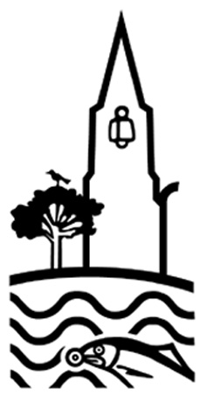
Stage 3

Celebrating Completion


managed by:
funded by:
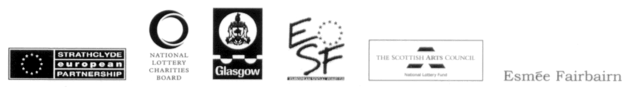

Final Report

Background
It was important to the board of Royston Road Project Ltd. that the celebrations of completion of the project were seen in context with the projects which were already underway at Royston regarding the artists commissioning, the residencies, the construction process (and related training and employment) and that the existing work and achievements were included/reflected in the final events.
We were aware from the outset, of the dangers inherent in creating public space in the area (vandalism and destruction are the usual results) and for this reason, the related artist residencies and commissions were an essential part of the project: not an “add on optional extra” – rather the key to long term success for the project.

Stage 3 also provided the board with the opportunity to celebrate the achievements of the parks projects, in partnership with the other complimentary and related project: the renovation of the Townhead Spire (managed by Glasgow Building Preservation Trust and Roystonhill Spire & Park Project).
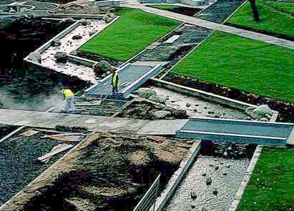

Molendinar Park nearing completion

During Stages 1 and 2 of the process, there had been both commissions (Graham Fagen and Toby Paterson worked within the design team in collaboration with Loci Design) and residencies (6 in total during the construction process).
The Commissions

The involvement of Graham Fagan and Toby Paterson in the design process resulted in both integrated input to the process of the plans and designs for the parks themselves. For example, Toby Paterson’s exciting and imaginative play/seating arrangements are as popular with the older generation as they are with the skateboarders and cyclists.
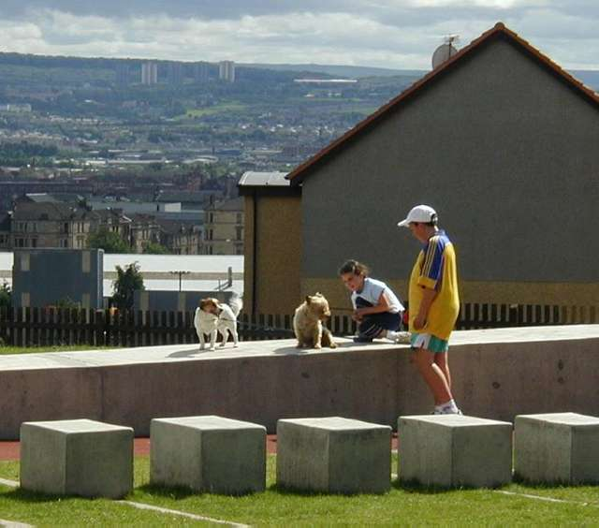

Their involvement also often resulted in more discrete projects. For example: during Graham Fagen’s “brand new rose for Royston” project, a new rose was created and a project called “the naming of the rose” ran in schools throughout the area involving young people in drama, movement and visual arts.

Spire Park users
At every stage the artists and the architects worked with community groups and representatives to create and develop the ideas; create the designs, models and plans and they were clear that their role was to provide the professional expertise which allowed community aspirations to be fulfilled.
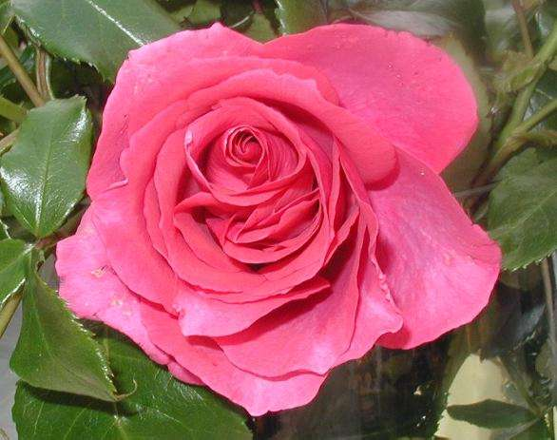

“Where The Heart Is”
The Residencies
In addition to the design team artists, there were six artists in residence: three within each community. The artists commissions related to the broader issue of public space; how it is built, designed and used. It was through these projects that the Royston Road Project aimed to nurture a sense of ownership of the new facilities as well as an understanding of the whole area as a public space – a place of beauty over which they have some ownership and can control.
Also, the arts led programme allowed the focus of the project to be expanded so that it embraced, not just the 2 new public spaces: but also allowed recognition of the whole area as the place in which we live, work, spend leisure and recreation time/engage in life-long learning opportunities and input into the creation of the aesthetic environment as well as the spiritual environment of the whole Royston Road area.
In other words, the artist residencies allowed people to develop a sense of ownership and pride in their whole community and some (e.g. Bolt FM) have moved into a new developmental stage and have taken on a life of their own.

Scott Myles was the artist in residence at the Library on Royston Road.
Scott is an exciting young artist who has already won awards and commendations and is highly regarded in the arts world.
He was based in the Royston Library and worked with individuals and groups throughout the area who use (or don’t use) the library. He discovered some fascinating political history through research: history which belongs to the local people and which few know about.
The library itself is a huge resource and in order to encourage more use of the facility, he has created a dedicated room in the library where local people can access historic archive information as well as information about the Royston Road Project -
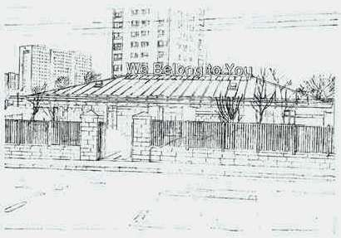

“We Belong To You”

particularly the Royston Road Project website: http://www.roystonroadproject.org/
A huge “We belong to you” sign is being mounted above the door on the roof of the library – also to encourage access.

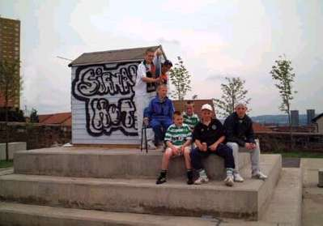
Paul Carter (another highly respected artist) worked with the Royston Youth Group.
Paul and his group created a project about “communication with extra terrestrial life”. Called “Signal Hut” They built a signal hut and sent messages into outer space (the spire lights will change colour when a reply is received!) and they launched their own “graffiti balloon” which took all their graffiti out of the park and into the cosmos.

The Signal Hut in the Spire Park
At the Blackhill/Provanmill end, Radio Tuesday worked with the Molendinar Drugs Project and others to set up a new local radio station.
Run and managed by local people, Bolt FM is one of the most exciting developments from the project.
The brand new Radio Station for North Glasgow broadcast for a week in May from St Paul’s Church. Many members of the local community turned out to support the team of lads and lassies who were training and running the station.

Members of the drugs project and some young people from Blackhill/Provanmill worked with “Radio Tuesday” learning new skills around the whole technology of radio broadcasting.
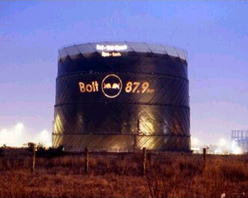

Bolt FM make an impression on North Glasgow

There was a strong programme, posters, car stickers and a fantastic projection onto the back of the Gas tower made up Bolt FM’s advertising campaign: and a SIP application has been successful for revenue funding (a development officer post) to continue Bolt FM after the end of this project.
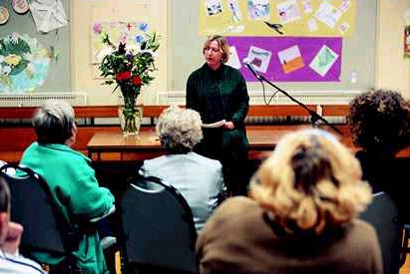
Jenny Brownrigg worked with the Molendinar Community Council and her project was a writing project.
“Romantic Vanguard” started with the focus on Mills and Boon with author Jessica Hart giving a talk about her work and the popularity of the Mills and Boon romance genre.
Participants had the chance to create their own pieces of personal writing and again, the project will continue in the New Year.

“Romantic Vanguard” at Molendinar Community Council.

Linking the strands: the final residency

The Board had realised from the outset that there was a need for a third phase: a process of participatory arts which would lead to a celebration of achievements.
While a separately funded and discrete project interms of the construction project, SAC had always regarded this part of the project as integral.
The Board therefore took the decision to link the final residency with phase three and ask the artist who took on the final residency to broaden the remit which would
include having an overview of the whole project and pulling all the strands together.

Eddie Ladd took on the remaining residency which created quirky and exciting material for the new Royston Road Project website.
Eddie’s residency started the process of bringing all the strands of the project together and preparation for the final celebrations. She therefore worked with local people from both communities (although her focus was within the community of Blackhill/Provanmill).

A series of around 10 clips from “films that were never made” or “lost films” from around the area: enigmatic, pointing to but never explanatory of, a narrative.
Working with local groups and identifying interested individuals, they were filmed on location: directed by Eddie – filmed and edited by a professional film crew.
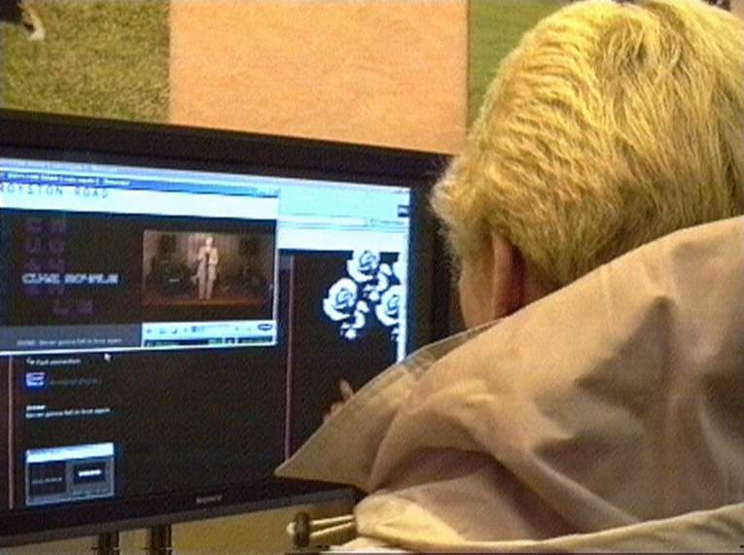

‘Irene’ watches her web performance on screen, at the launch

Also part of the project was a process of documentation of events generated by people in the area.
Working with local groups, Eddie identified what events were going on/researched what's on and where, and she and her crew filmed and edited the results for the web.

Finally, Eddie focused on the parks, encouraging local young people to take her on journeys through the neighbourhood (narrating, describing, introducing the local characters etc.) and into the parks every day to film how and when they're used over an extended period: accidental events and casual use, interesting and imaginative ways in which kids are playing in the park etc.

The results of Eddie’s work is able to be viewed on line in the performance section of the Royston Road Project website ( http://www.roystonroadproject.org )

Stage 3: The final process and celebratory event
Aims
The arts work so far had been linked to the construction of the parks. The goal now was to bring all of this work together in a programme of activities and final events which would allow the whole community: young, old and everyone in between to congratulate themselves on their tremendous achievements and to be totally involved in celebrating the opening of these two new, top quality public spaces for the area.
* Stage 3 aimed to scrutinise issues around the appropriate use of the two new public spaces and the celebration of their completion. The aim was to ensure their long-term viability by firmly establishing ownership within the broader community.
* Stage 3 aimed to raise questions around ritual: what are the rituals/events that can be initiated to allow these parks to be firmly established in the daily lives of the people who live in the area?
* Stage 3 aimed to bring together all the different groupings within that community in a sense of commonality: the different geographical communities along the Royston Road: the denominational religious communities and all the different cultural strands of the indigenous Scottish population and the new cultures and ethnicities (many of whom are asylum seekers from troubled parts of Europe) as well as the different professional and business communities: consultants, professionals, management committees; artists, architects and funders who, in partnership with the Board of Royston Road Project had been responsible for realising this major achievement.
* Finally, Stage 3 aimed to place the achievements in the wider context of the city of Glasgow (which is the richer for the development of 2 new public spaces and the restoration of 2 very important landmarks for the area: the Townhead Spire and the Molendinar Waterfall) and internationally (Royston Road Community Parks Project has provided an example of practice for European regeneration programmes which are arts led and community driven).

Objectives:
The background theme was the celebration of the realisation of the Parks, but we also had a brief to look at how to keep that new public space safe, how to engender an ongoing sense of ownership and care, and how to use the pride in the new developments to encourage a sense of community space about the whole area.
Finally, and most importantly, stage three had to reach the widest section of the population possible: in particular, those who fall within the remit of the Glasgow North Social Inclusion Partnership.

The Board therefore decided on 2 objective priorities in the realisation of the aims:
- The creation of Royston Road Project’s own interactive website
- The staging of a celebratory event(s) which would be inclusive, high profile and in which participants would take pride

1. The Web site
The web link The web link is a vital part of the whole: it links the artist residency programme from stage 2: (one of the residencies is actually based in the library and utilises internet with community participants; some of the residencies use video as the medium of expression and all of the residencies are being recorded on video).
Most importantly, it addresses the social inclusion agenda: putting Glasgow North in touch with itself and with the rest of the world.
During the final events, this footage was accessible on the web – locally, nationally and internationally.
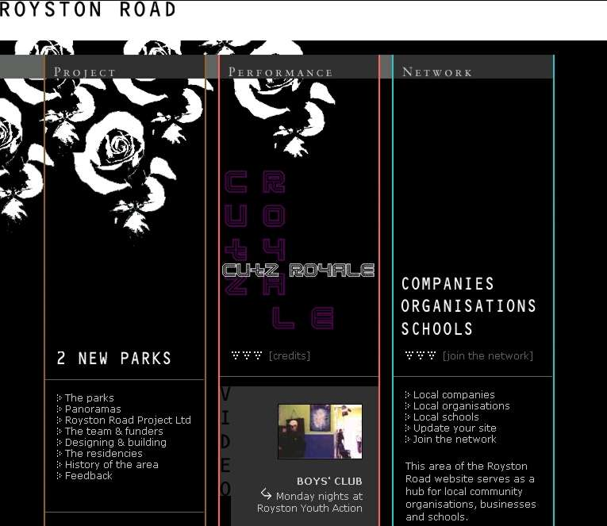
The first step towards the creation of the web site was the appointment of a web site designer (Chris Evans) and co-ordinator (Robin Gillett).

In partnership with the Royston Road Project Board, Chris designed a site which is as accessible and user friendly as it is beautiful to look at and to navigate around.

The main page of the website
Content:

The web site has three sections

1. Archive
Called “PROJECT”, the archive section of the Royston Road Project website contains footage of historical development of the Royston Road Project: news reels of the catalytic community action around saving the Townhead Spire, development of project, stages 1 and 2 etc., the construction of the parks, the employment and training programmes, the artist residencies as well as a piece on local history written by historian and local resident Jim Friel.

As present and future developments pass into history they will in turn be added into this section: the celebratory performances and events, the Gillian Steel documentary of the project, and so on.
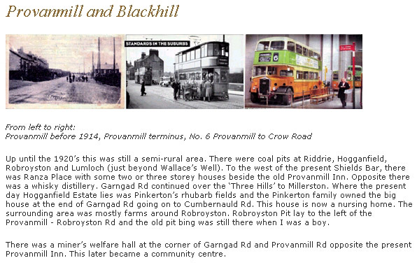

Part of the website page on Provanmill’s history

2. Eddie Ladd’s project on line
Called “PERFORMANCE”, this section of the site has created space and video streaming for Eddie Ladd’s project results as described above: short documentary films/footage of people using the parks/quirky narrative projects etc all created by groups and individuals.

The organisations involved were: the Royston Rag, Northern Rock (music for the web), Toonspeak Young People’s Theatre, the Molendinar Drugs Project, Royston Youth Action, Bolt FM, St Paul’s Youth Group, St Paul’s Music Group, the Molendinar Community Council as well as various individuals from both neighbourhoods.
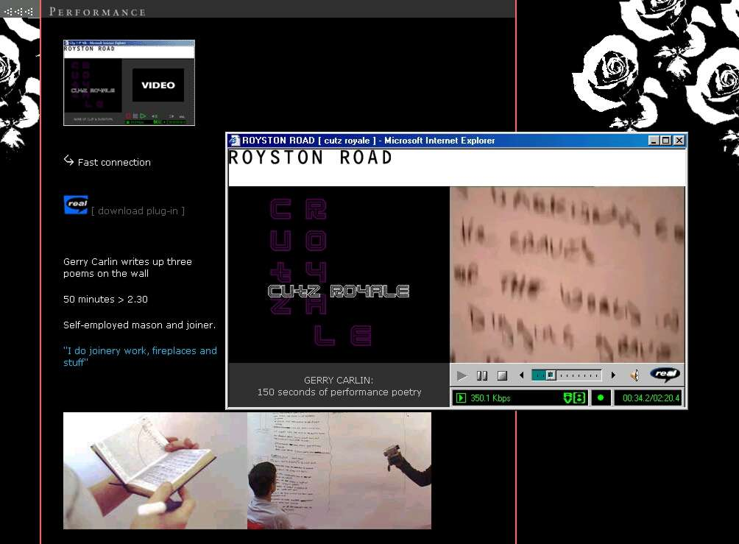

Eddie Ladd’s “Cutz Royale” film of poet Gerry Carlin
3. Hub
The Hub section (called “NETWORK”) is devoted to the wider community:
We have been working in partnership with Glasgow North and North Glasgow Social Inclusion Partnership to identify organisations/schools/community groups/local businesses throughout the Royston Road area who don’t yet have their own websites.
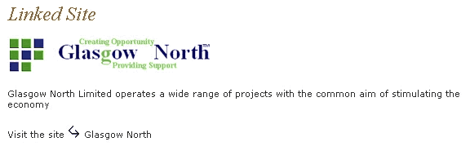

Example link from the “Network” to an existing website

The project is offering these groups/companies/businesses/organisations the opportunity to create their own site (using a template and under the guidance and professional expertise of Chris Evans (website designer), Stableyard and Robin Gillett.
At the time of writing this report, several schools and community businesses are already working with Chris on their own sites and this process will continue into the new year.

These new sites will have links to businesses who already have their own sites as well as any relevant networking agencies/funding bodies etc. (a database driven process) and everyone will be offered training in updating their own sites.

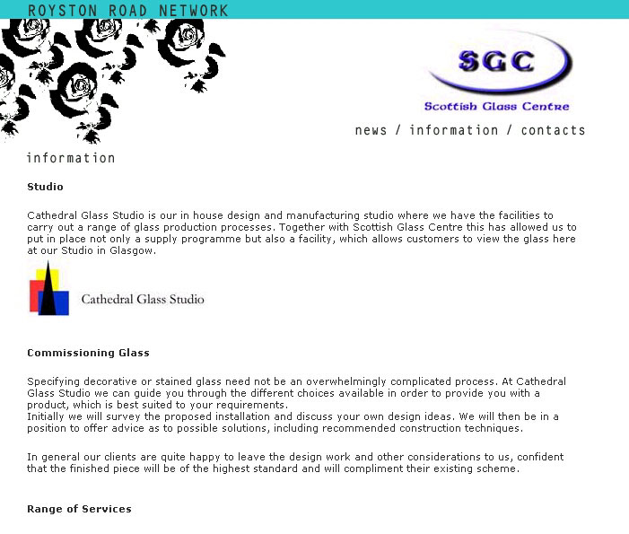
“Scottish Glass Centre” on the Royston Road “Network”
Access to the Web is a very important issue: We will ensure that there are at least 2 access points in the community for people to log on: dedicated computers (bought out of the project budget) which are fast enough for the process not to be frustrating. These 2 computers will remain in the area permanently after the end of the project. Assistance is also being given to set-up high speed internet connections to these locations. In addition to these points (in St Paul’s Church already, and hopefully Roystonhill / Rainbow Hall soon) we are working together with the City Council’s Libraries & Lifelong Learning service to link to the Royston Road Project site, and help publicise the free web access available from the two local libraries in Royston Road and Riddrie.
The RRP website went live on line on Wednesday, 12th December 2001. Robin Gillett (co-ordinator) reported that night that there had already been 279 “hits”.
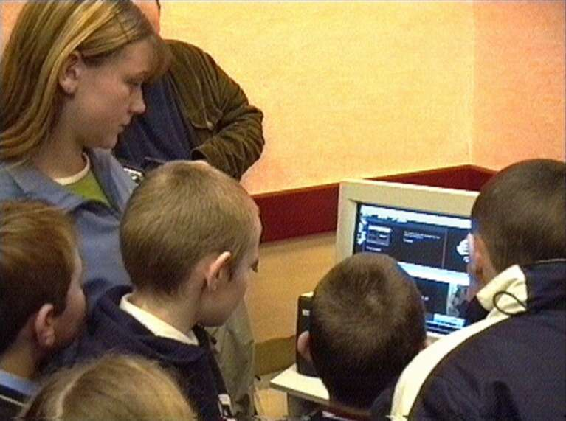

Surfing the RRP website
The Wise Group Partnership
The Wise Group have been major partners in the whole Royston Road Community Parks Programme: from a consultancy role in the early days, the Wise Group are the main contractors as well as co-funders of the project (they have run a training programme involving 22 unemployed people, 75% of whom are local to the specific communities involved) and have provided employment for local people in an area which is statistically amongst the highest in Europe in terms of unemployment.
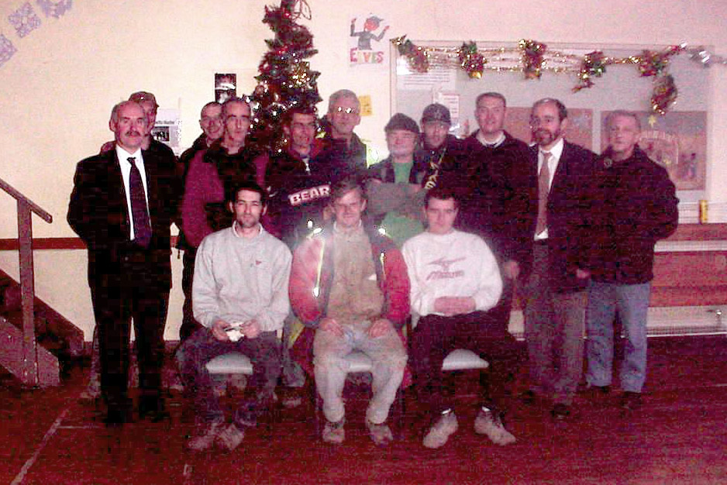

Trainees from the Molendinar Park

One of the Wise Group’s complementary programmes is an arts programme where freelance arts workers are contracted on various projects to enhance the environmental improvement and training programme through an outreach arts education programme involving young people (mainly through the schools).
The aim of these programmes almost exactly complements the Royston Road Projects’ and it is visionary and cutting edge that a training for work construction company can see the value of engaging with the arts. They aim to encourage young people to take pride in their new environment, to own the improvements and to work in partnership in the future developments.
Therefore, for Stage 3 of the Royston Road Project, in addition to the programme as described above, there was a schools and community groups workshop programme of arts activity being funded and managed by the Wise Group which worked in tandem with and fed into the whole stage 3 arts programme.
Bazooka Arts were appointed by the Wise Group and they (with a Wise Group community outreach team) worked for 3 months in three of the 5 primary schools as well as with several community groups throughout the length of the Royston Road.

Performance Project

The theme was “Park Life” and the young people created scenarios which celebrated happenings and events which have taken place in the parks and may (or may not!) happen in the parks in the future.
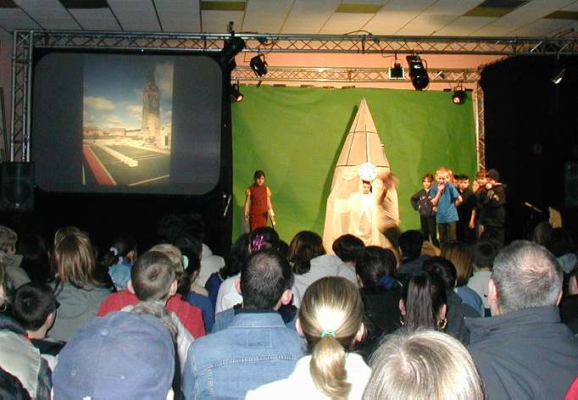
Everyday events like alien landings, circus performances, strange hauntings and ghostly apparitions at midnight, live T.V. broadcasts etc. were written, devised and performed by the young people themselves.
The main aim of the process was to provide a programme of creative drama which would enhance the curriculum, encourage confidence and self esteem amongst (sometimes very marginalised and excluded) young people as well as teach skills in all the creative arts.

The programme also had an underlying aim which is a commitment to bringing together the young people from every community and from every denomination/race/culture/ creed in a unity of purpose and vision: the creation of a positive future for their community (its physical environment and the people who live there).

For the final events, Bazooka Arts brought together all the schools and community groups who had participated in the “Visions for the Future” project: the performers, the performance pieces, the costumes, props and the family, friends and the wider network contacts of the young people who had created the performances. Also invited were the rest of the school populations, staff etc, in an atmosphere of celebration both of their achievements and their community spirit.

Bazooka Arts Show (in Rainbow Hall)

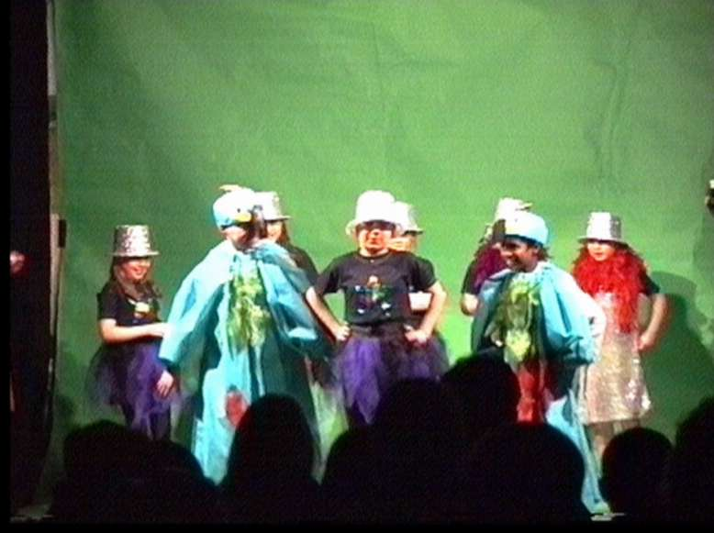

The Parrots

The “Visions for the Future” performances formed a major part of the Royston Road Project final events and will be included in the archive section of the website. The pieces were performed on the two nights as part of the web site launch event (6.00pm each night: Wednesday in St Paul’s Church, Thursday in the Rainbow Hall) at the top of the evening: complementing the opening celebrations for the parks.

They were supported by Eddie Ladd and a technical team who provided blue screen and slides/footage of the real parks: the whole process culminating in live sequence interspersed with the pre recorded footage based around the parks made to look as if the actors were actually walking in the parks... a delicious blend of the real and the virtual.
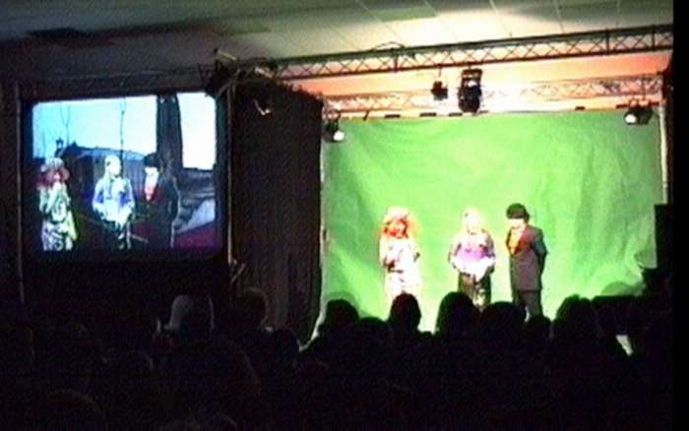

“Rant & Reck” in the virtual park.

Time Capsule Project
Just as the Naming of the Rose project had created a groundswell of healthy competition and sense of ownership of the new Royston Road Rose (“Where the Heart is” was the name which was suggested by a pupil at Royston Primary School and chosen by a committee), so the creation of a time capsule for the Molendinar Park achieved similar results.
Pressure of work/other commitments meant that in the end only Littlehill Primary School (the school which faces onto the new park) was able to participate in this project but even so, it was very worthwhile.
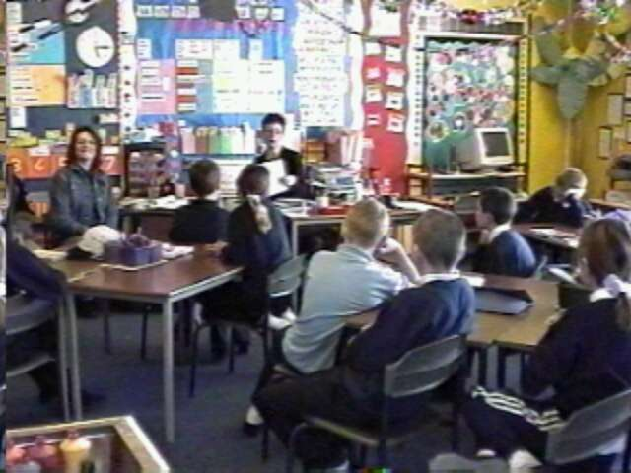

Littlehill Primary talk about the time capsule

Committee members from the Royston Road Project shared their thoughts and aspirations for the park with Primary 6 and 7 who then went off for a week to Castle Toward where they experienced the great outdoors and thought about their own park at home. On their return, they worked with their class teacher to create an exhibition of paintings, writing, poetry and photographs (displayed in St Paul’s on the opening event night), copies of which were placed in a time capsule and “planted” in the park during the opening ceremony.
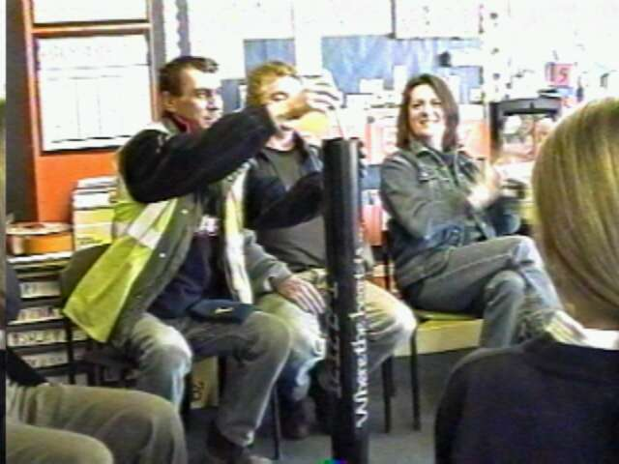
The “sealing the capsule” event took place in school and involved the young people describing their research, reading their poems and stories and placing them in the capsule. Also involved were members of the team of trainees: local men employed by the Wise Group who had built the park. Everybody present (young people, construction workers and the board) committed to looking after the park in the future and “keeping it safe” together.
Sealing the time capsule at Littlehill
The Final Events
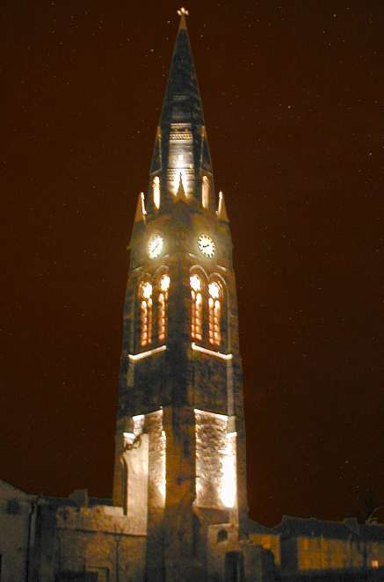
Although the Spire Park had been completed since the summer, the Spire itself was still undergoing refurbishment under the management of Glasgow Building Preservation Trust and the Spire and Park Project committee.
The Molendinar Park was racing towards completion in time for the opening celebrations on the 12th of December and everyone was clear as to the desirability of having joint opening celebrations of completion over the 2 nights of the 12th and 13th of December.

The challenge was to bring all of the elements (and all the different partners) together in a celebration which was cohesive and which honoured the contribution of all parties as well as create ceremonies which “marked the occasion”: officially opening both parks, planting the time capsule in Molendinar; switching on the spire lights at the Spire Park and launching the Royston Road Project website.

The newly lit Spire
The results were enjoyed by up to 500 residents, parents, partners, funders and participants each night and combined the website launch with the official openings of both parks (and included the switch on of the flood lights in the Spire)
On both nights, the evening started with the “Park Life” performances. The performances were followed by the launch of the website: a chance for local people to access the different strands and play about with the possibilities (as well as enjoy tucking into a delicious buffet).
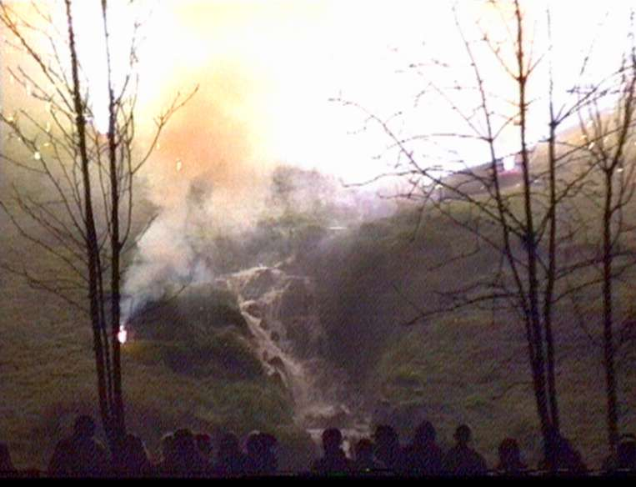

Molendinar waterfall illuminated by fireworks
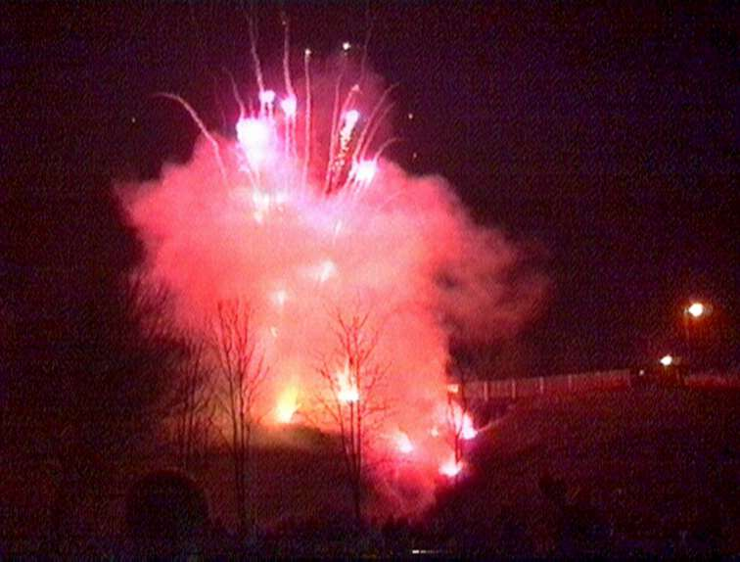
Having spent the evening watching performances in the virtual parks and accessing images of the parks on the web, the evenings ended in the real parks: theatrically lit and with music from Bolt FM and local bands, drumming (from Northern Rock’s percussion band) and fireworks.
It was important to be in the parks both virtually (daytime) and in reality (at night) to see and experience some of the many possibilities for their use (play, performance, recreation, the possibility of magical “happenings”) and also to take some of the feeling of threat away from being in the park at night.

The Molendinar Fireworks
Marketing
The community was able to follow the process of the construction phase of the project and all the related arts activities through a series of postcards documenting progress, which were distributed regularly to every household in Glasgow North via the Royston Rag.
This process continued throughout the final residency programmes and Stage 3 of the project: the cards continued to keep the whole community informed of major and minor events/happenings at every step of the way and there is still some funding in the budget to produce a final card which will feature the opening celebrations.
Evaluation
A priority for the RRP board was evaluation of Stage 3 and that some kind of innovative approach be developed.
Lia Ghilardi (who has provided the interim evaluation) worked with Sarah Longfield (director of Toonspeak Young People’s Theatre) to create video diaries, wish boxes and other evaluation tools for the 2 nights of the event.
The results and findings will contribute to final evaluations: a conference, a publication and a major exhibition planned for The Lighthouse next year.

a. Conference
The Board is working with Andrew McQuaker at SEP to develop a conference event scheduled for March 2002. Each strand of the evaluation will have a “voice” and each voice will be co-ordinated by a nominated leader:
Community voice: Sara Longfield, Artists voice: Lucy Byatt,
Board voice: Russell McLarty, Funders voice: Liz Gardiner,
Independent/objective voice: Lia Ghilardi.
The conference will be an opportunity for the same cast from the celebrations of stage three to come together in a more reflective mode: the board, the community representatives, the funders, consultants, contractors and artists.

b. Publication
The voices will be pulled together with a linking web of narrative, punctuated by some of the most appropriate images from the project and will form the basis of a prestigious publication, which will be launched at the conference in March.

c. Exhibition
Leoni Bell from the Lighthouse is working with Lucy Byatt and the Board towards a prestigious event in the Lighthouse in June to coincide with Architecture week when there may also be some additional funding and publicity.
We have the possibility of an exhibition in the exciting1st floor space where the Homes for the Future exhibition was sited.
There will be internet connections for viewing the website, Gillian Steel’s documentary film of the project will feature, as will the publication and other images

The board are currently engaged in the process of creating an application for the Arts Council which encompasses the conference, the exhibition and the publication.

Conclusion
The Royston Road Community Parks was a hugely ambitious project.
Stage 3 and the final events were a fitting culmination for the process: ambitious projects; ambitious events: the political made personal with strong community involvement and the launch of a project website of real class.
It was, also, after much work, discussion and refinement, technically and financially achievable.
Finally, although the parks are now opened, the Royston Road Project is very much looking to the future: the next stages – new projects and new opportunities to build on the work which has been started in developing the community through the medium of the arts.

Liz Gardiner
16th December 2001

